General Firmware functionality:

General Overview

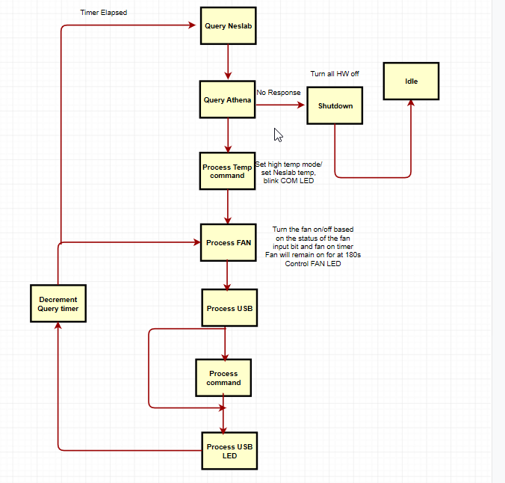

LED Operation :

Thermal Controller LED operation V1.7

|  |  |  |
| --- | --- | --- |
| **LED** | **Color** | **Operation** |
| LED 1 – Serial COM | White | Toggles on/off every time a successful command was sent/received from Athena. Solid White on communication failure to Athena |
| Led 2- Fan Status | Green | Green indicates Fan is on |
| Led 3 – high temp | White | High temp mode |
| Led 4 –USB status | Green | Blinks green on successful USB connection. Solid green on USB failure |

Firmware Load instructions:

**Current firmware V1.7**

**Installing the bootloader**

* Open MPLABX
* Select File import and selct the UBW32_HIDBOOT_MX460.hex file
* Select project UBW32_HIDBOOT_MX460 and right click it. Select “Set as Main Project”

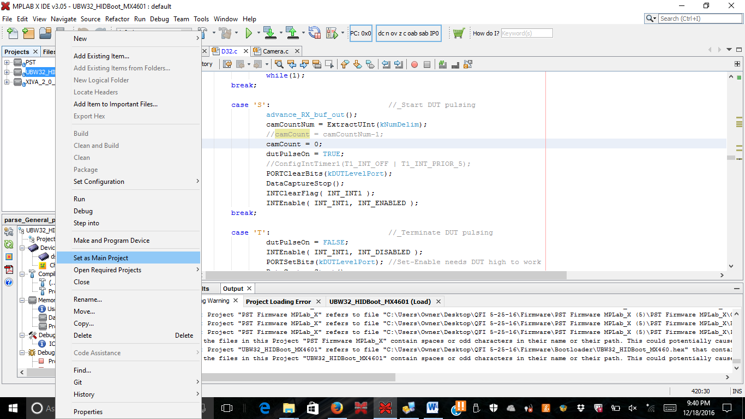

* Plug the PICKit 3 into the 6 pin header n the thermal board. Power the thermal board by an external 12V supply or USB connector
* Right click the project and click “Run”. This will load the bootloader.

**Installing the firmware**

Note: In order t load the PST firmware the PST Bootloader needs to be installed.

* Jumper connector X2
* Plug the USB cable into USB port on the thermal micro controller board and connect to the other end computer.
* Open Microchip USB HID Bootloader v2.6. The “Open Hex File” should be enabled. Click this button.
* Navigate to the Thermal hex file.
* Click “Program/Verify”
* 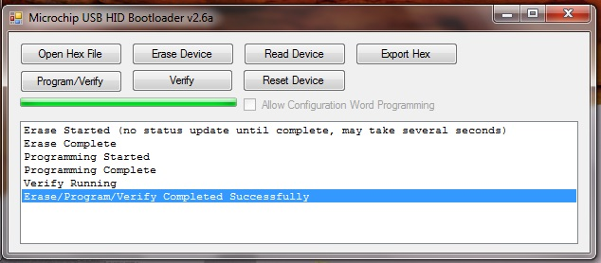A successful program – refer to figure 1

Figure – Successful